22.38: a) 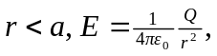 since the charge enclosed is Q.
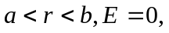 since the –Q on the inner surface of the shell cancels the +Q at the center of the sphere.
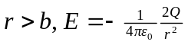, since the total enclosed charge is –2Q.
b) The surface charge density on inner surface: 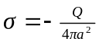.
c) The surface charge density on the outer surface: 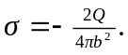
d)
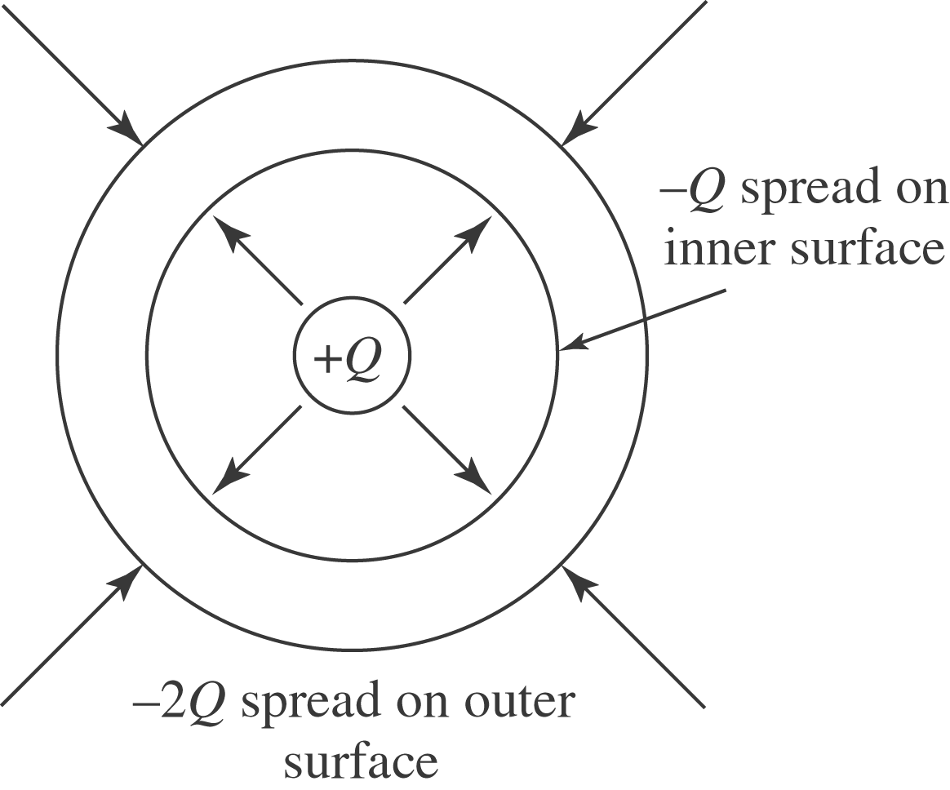
e)
